TP4 AAS

Atomic absorption spectrometer

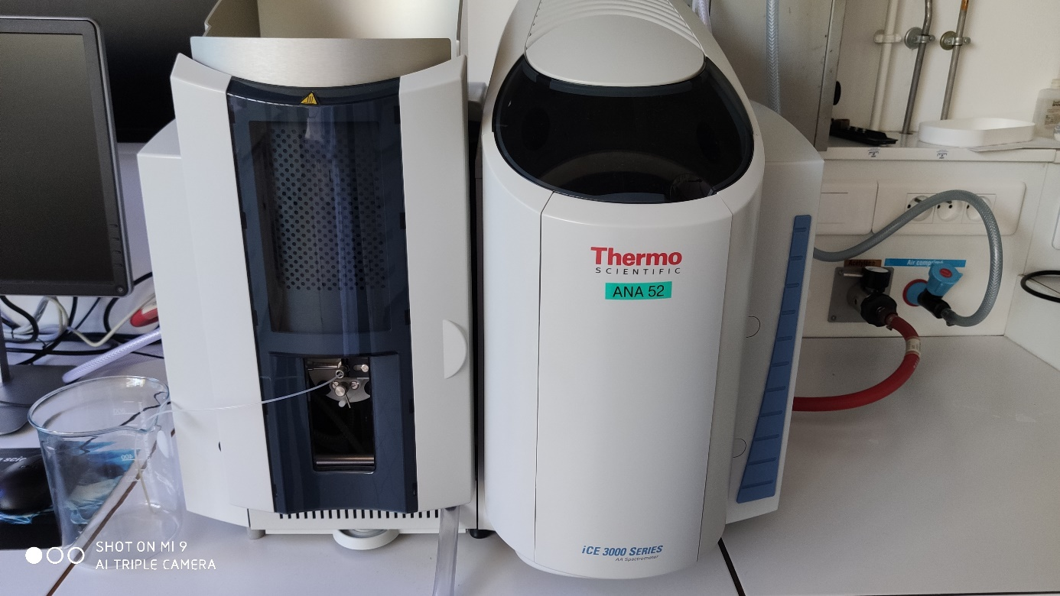
Compressed air
Acetylene
Sampling capillary
Figure 1 Spectrometer
This instrument is controlled by the software Solaar.
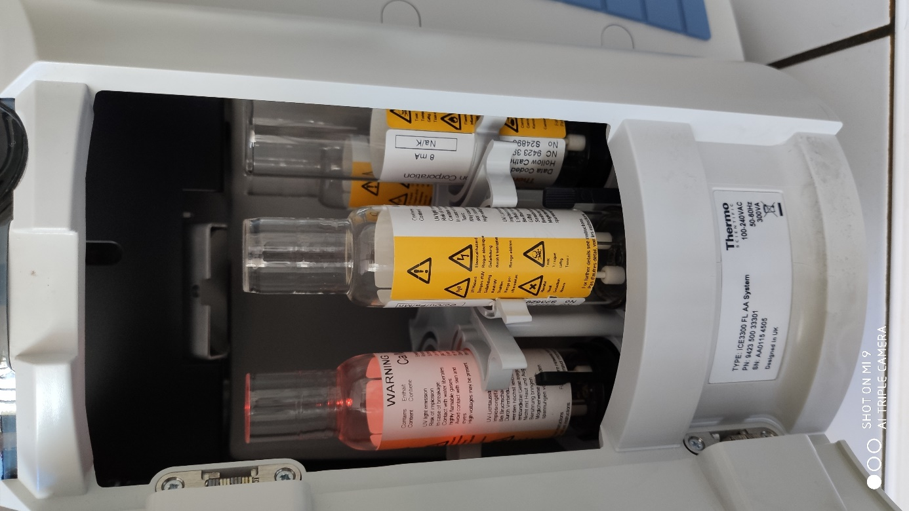
Hollow cathode lamp on
Figure 2 Carousel of hollow cathode lamps
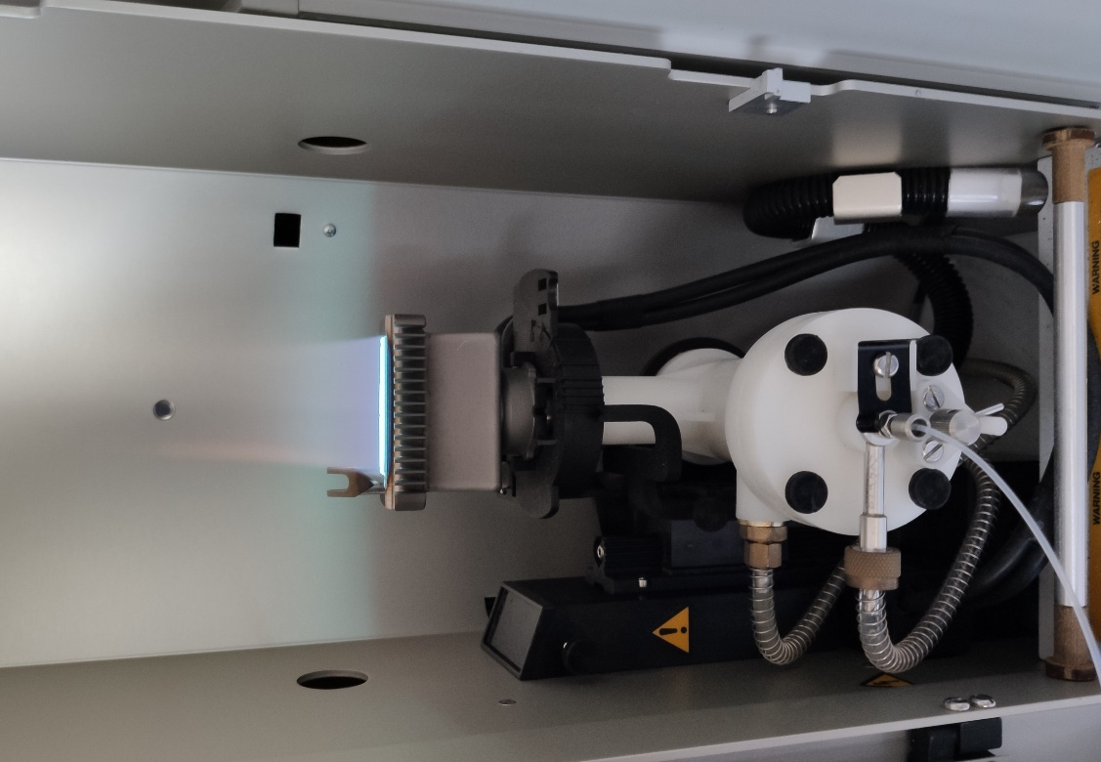
Compressed air
Acetylene
To the detector
Nebulization chamber
Inflow
Torch
Figure 3 Torch

This instrument can be used as an absorption atomic spectrometer or as an emission one. A video was performed to show the color of the flame with different elements.

