TP1 IR

Spectrum BX

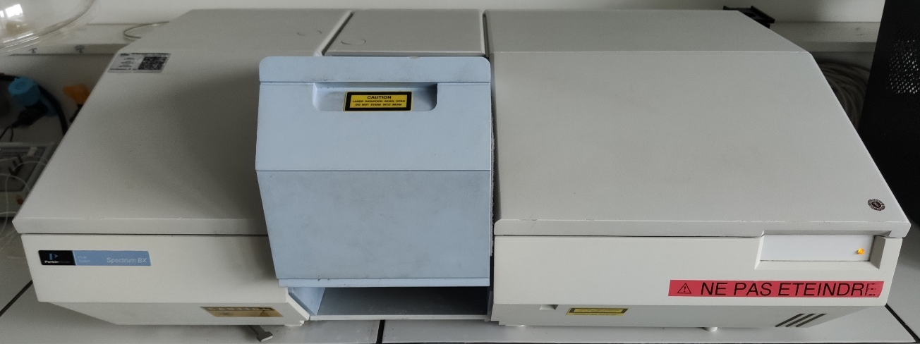
Figure 1 IR spectrometer

Polystyrene film

Figure 2 Polystyrene film
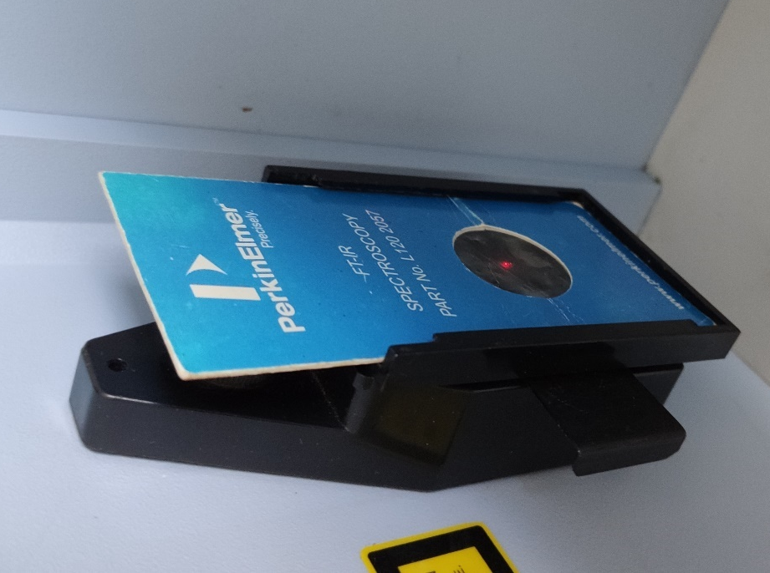
Laser beam
Film

Figure 3 Position of the film in the instrument

Liquid sample

NaCl plates

Figure 4 NaCl plates
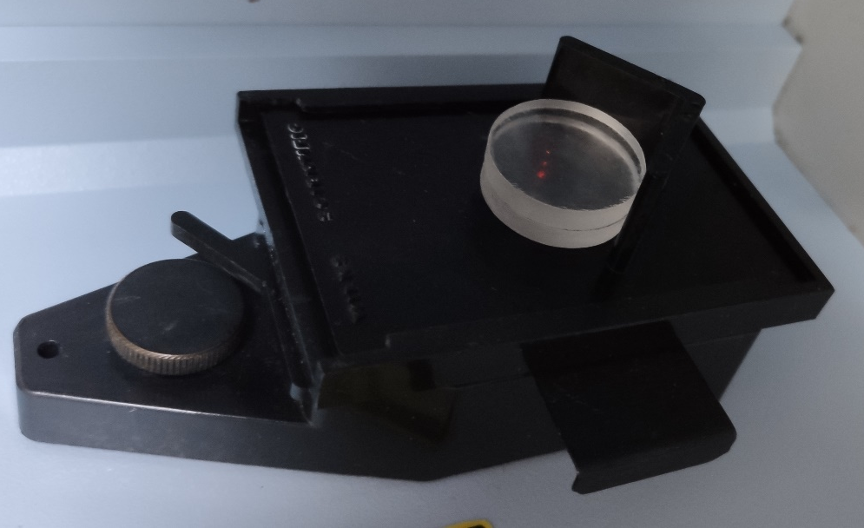
Methyl oleate film between NaCl plates
Figure 5 Position in the instrument

HATR

Methyl oleate on HATR
Figure 6 HATR in Spectrum BX

4.Solid Sample

Figure 7 Tool to prepare a KBr thin transparent solid film
Thin transparent solid film part
Lower part
Upper part

Figure 8 Parts of the previous tool
The preparation on a thin film of KBr will be performed in a video on Moodle.
KBr thin film
Figure 9 Position in the instrument

5.HCl

A video was made to show how to make HCl gas on moodle.
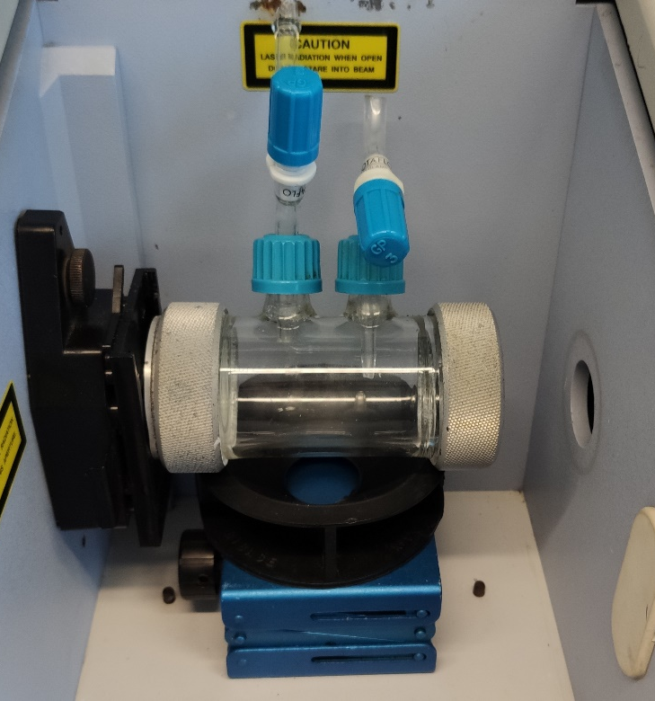
Figure 10 HCl cell in Spectrum BX

6.Diesel

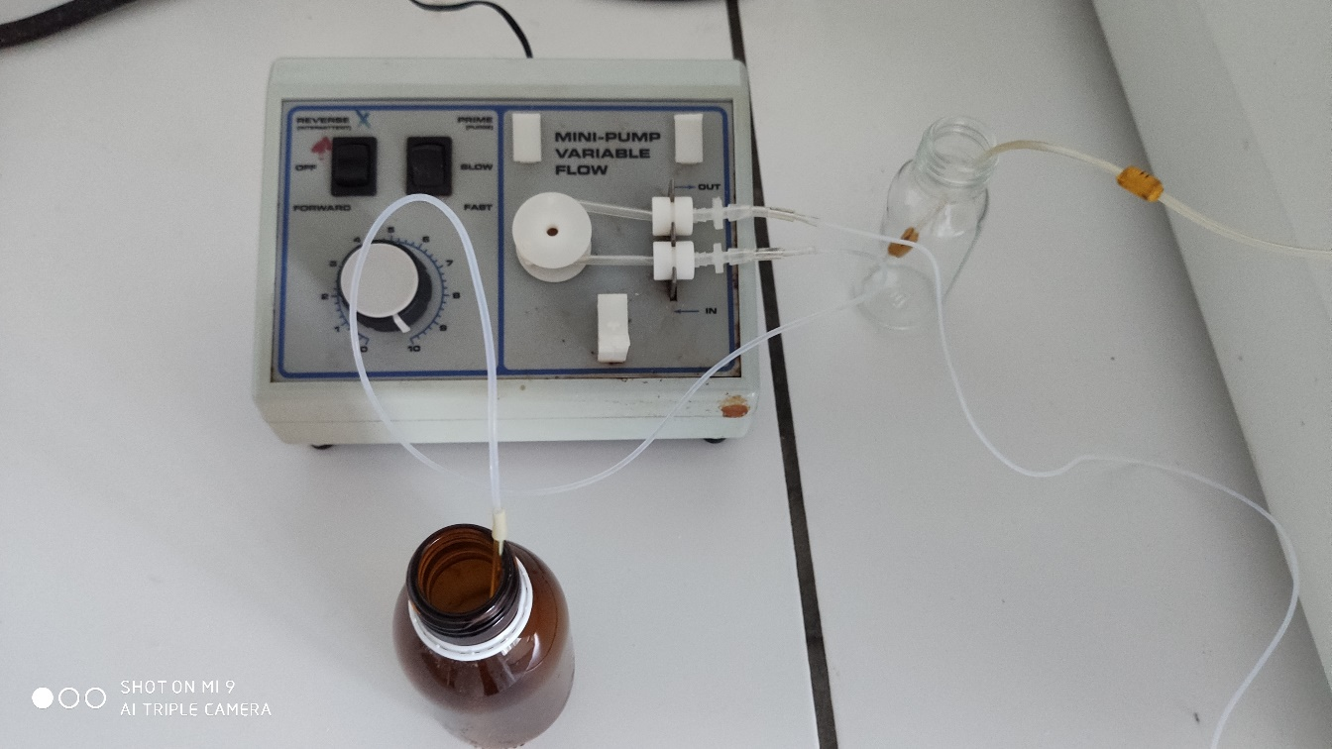
Outflow
Inflow
Trash
Pump

Diesel or cyclohexane
Figure 11 Pump system for Diesel
Diesel film between 2 glass plates
Outflow
Inflow
Figure 12 Front of the cell
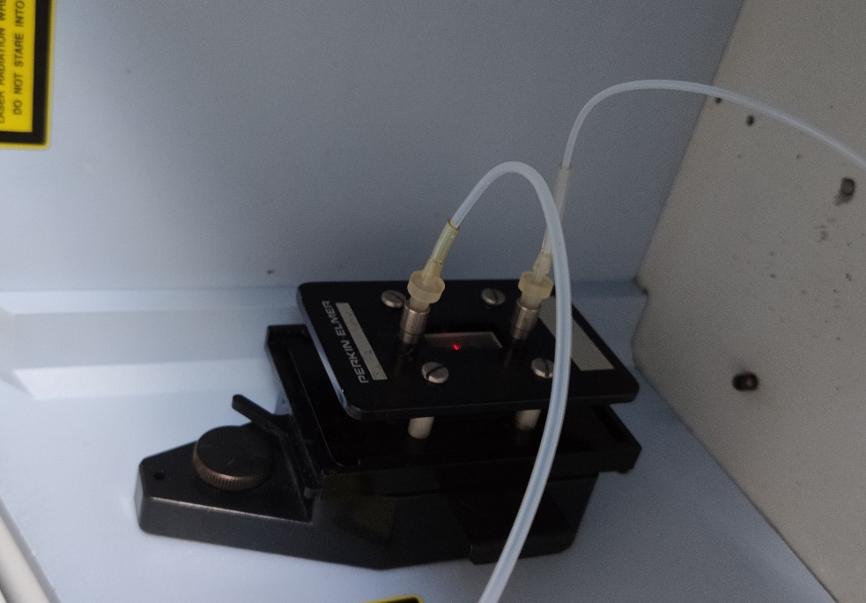
Diesel film
Outflow
Inflow
Figure 13 Cell in the instrument

