TP5 Molecular Emission Spectrophotometry

Spectrophotometer

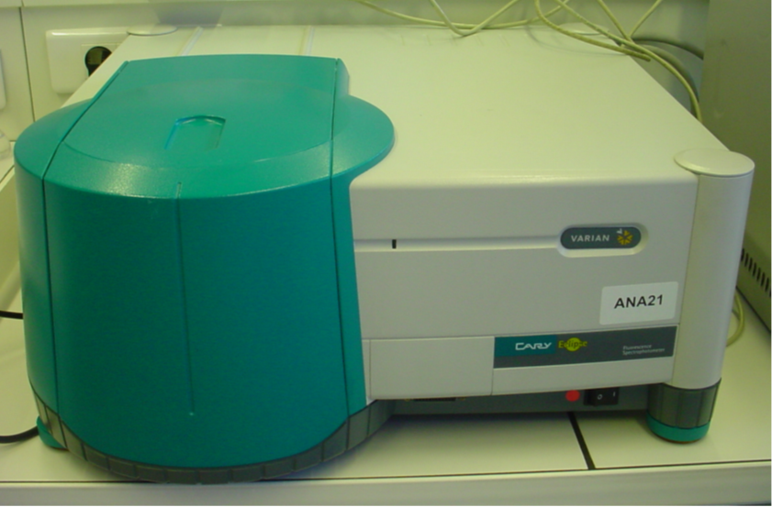
Figure 1 Instrument
This instrument is controlled by the software CARY Eclipse.

Cell
Figure 2 Front and side of the cell (Both clear)
Cell is fragile, it’s made of quartz and costs around 150€.

Cell in the instrument

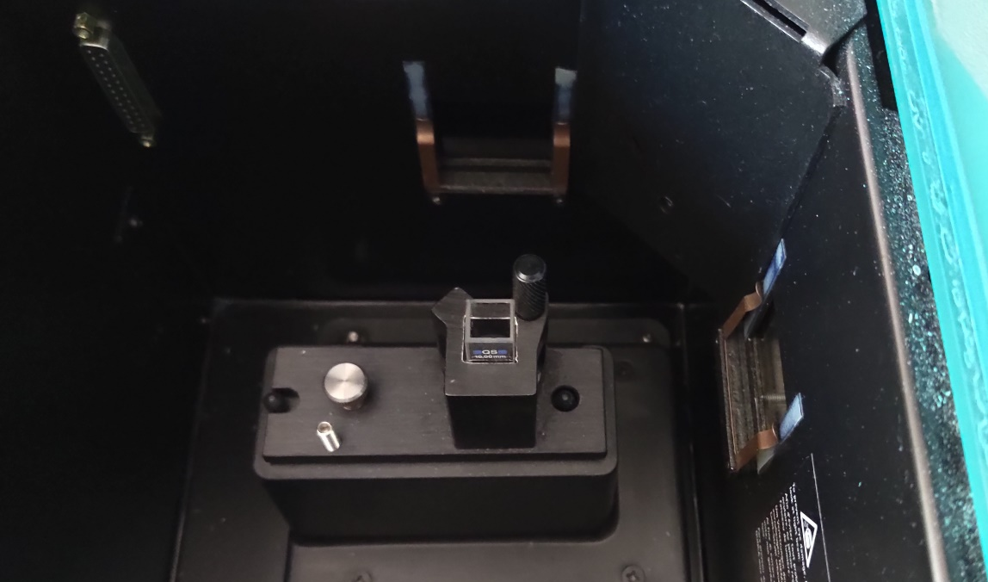
Emission beam recorded
Incident beam
Cell
Figure 3 Instrument from above

