**TP2 GC**

# Scion 436-GC

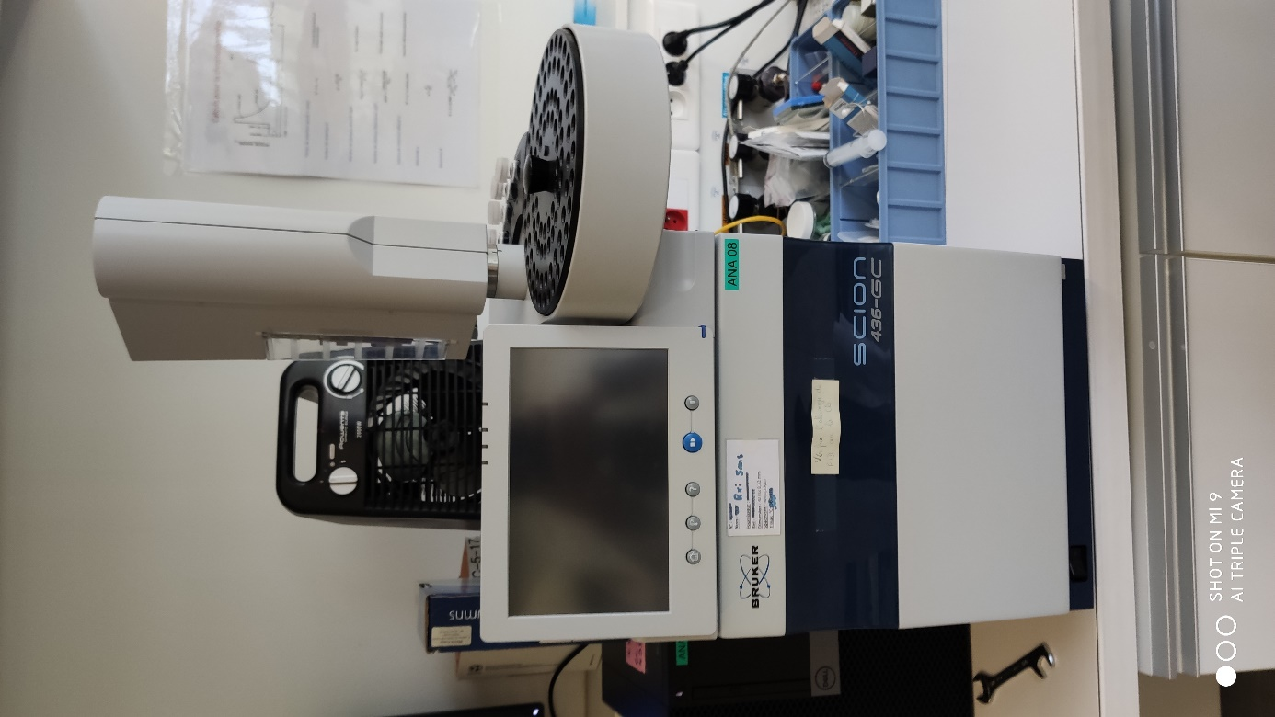

Autosampler

Control panel

Oven and column

Figure 1 Instrument with sampler

# 

To detector

From injector

Figure Oven and column

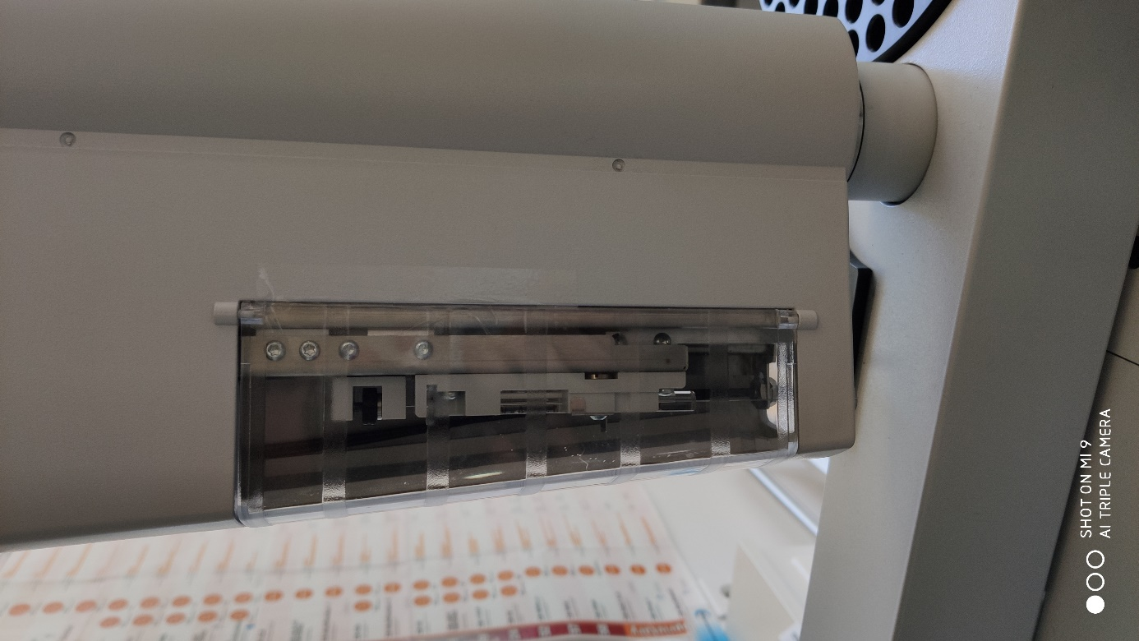

Syringe

Figure Syringe in autosampler

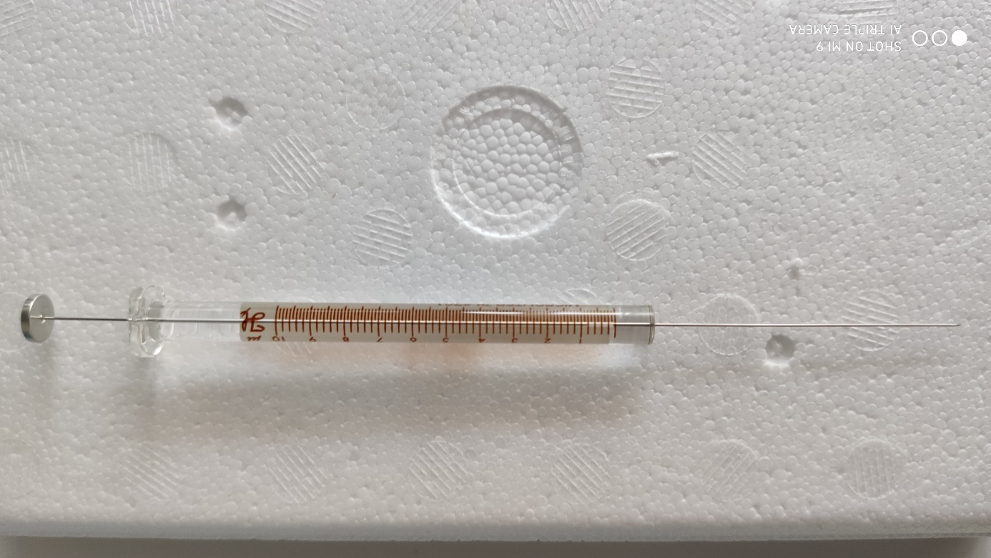

Figure Syringe

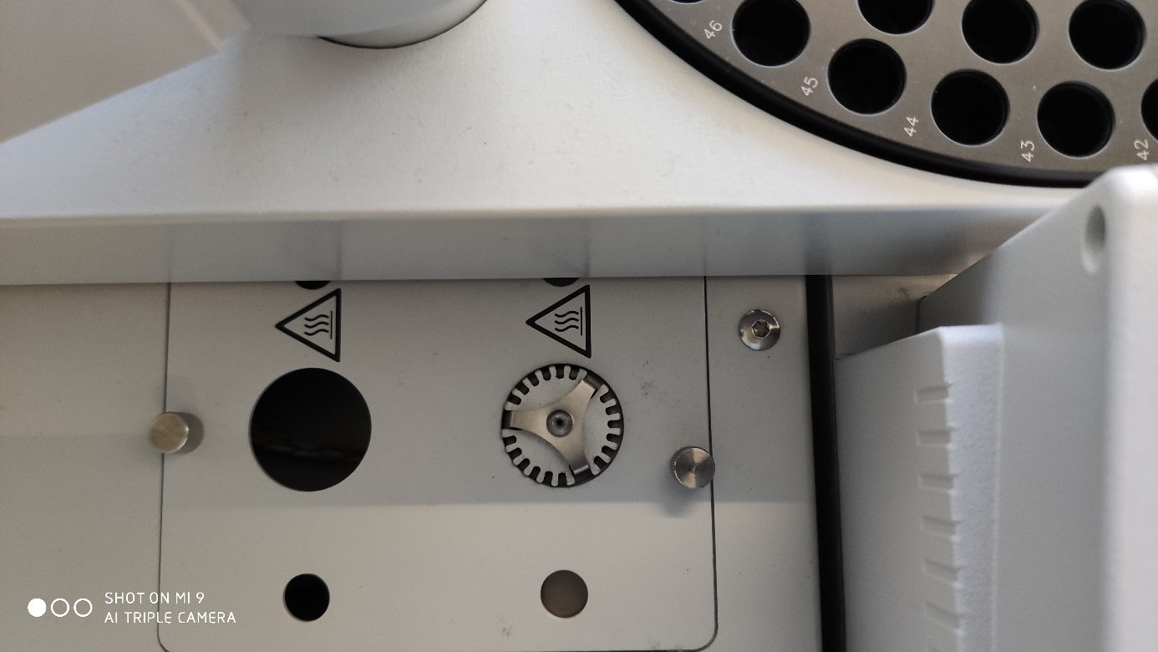

Figure Injector

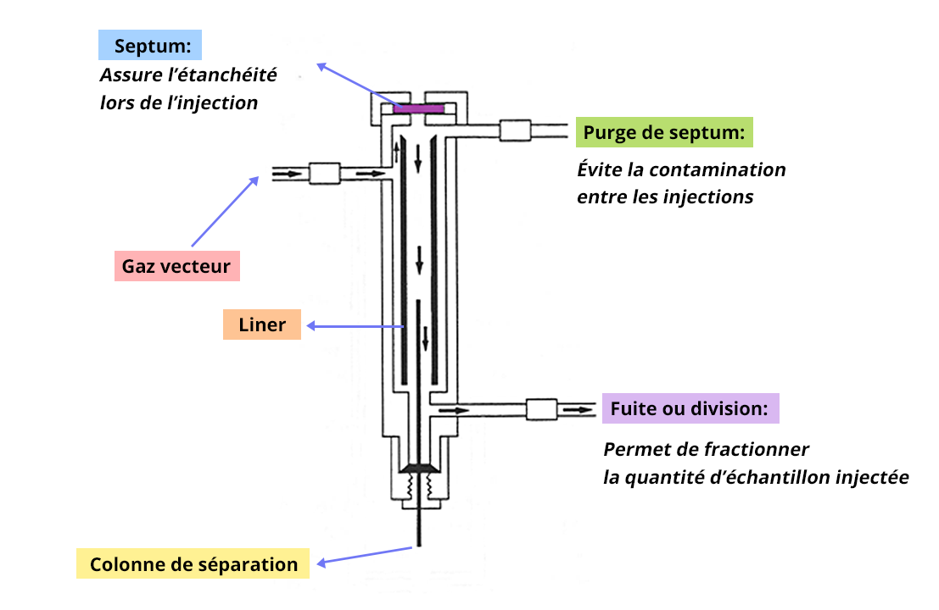

Figure 6 Diagram of an injector split/spliless

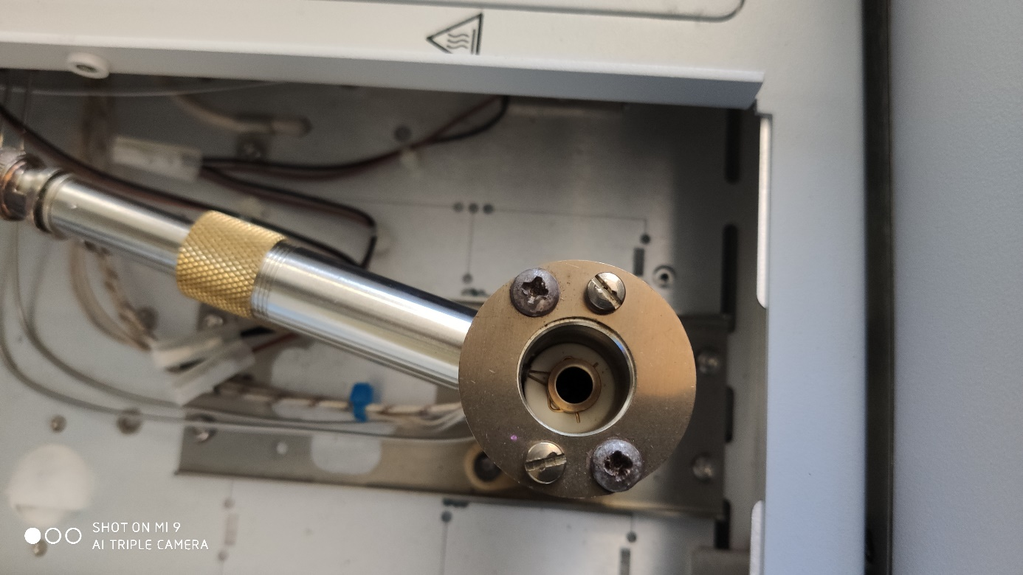

Figure Flame Ionization Detector

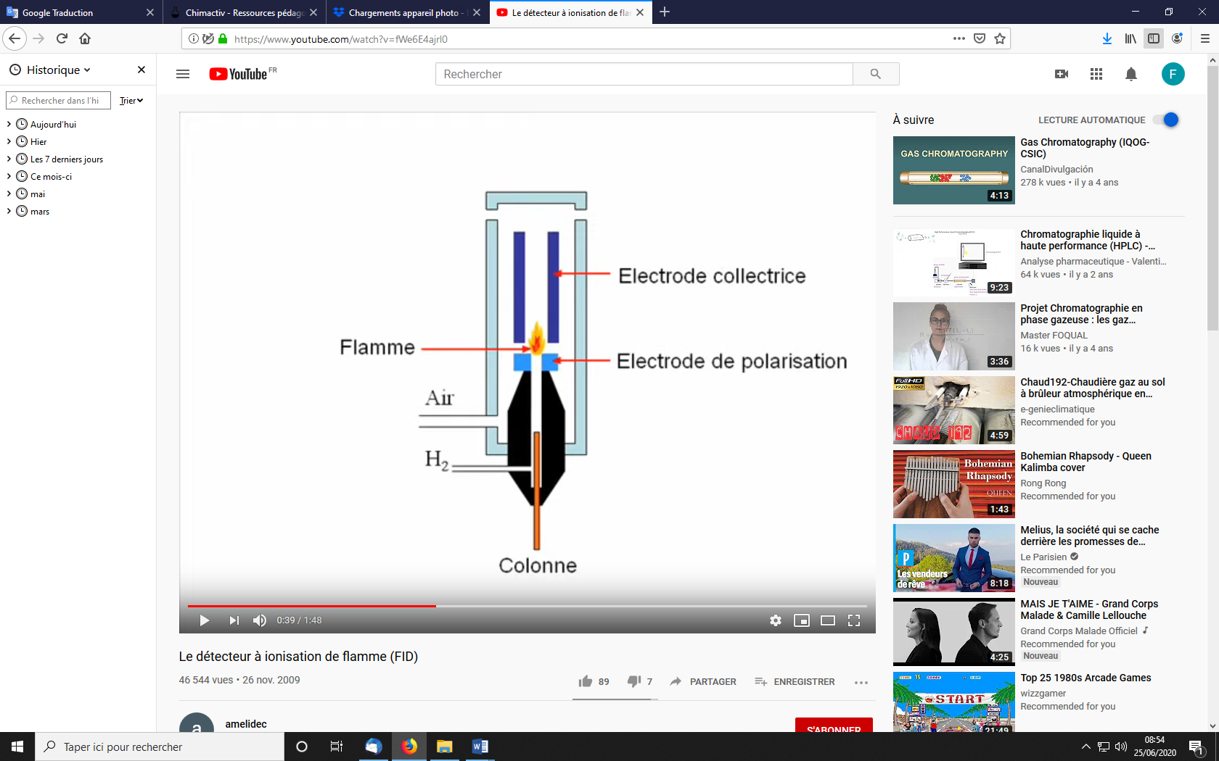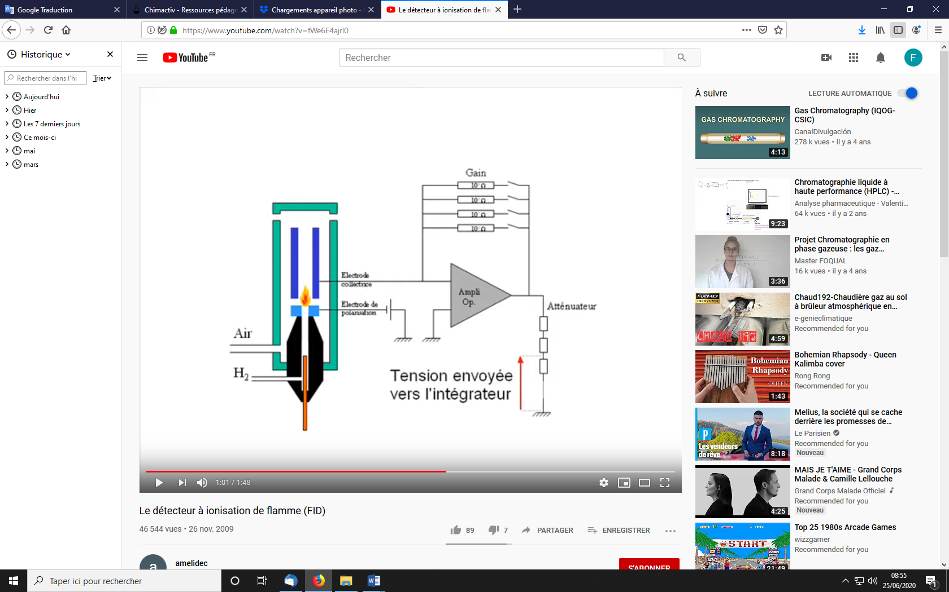

Figure -9 Flame Ionization Detector diagram