TP3 UV

UV-Visible spectrophotometer

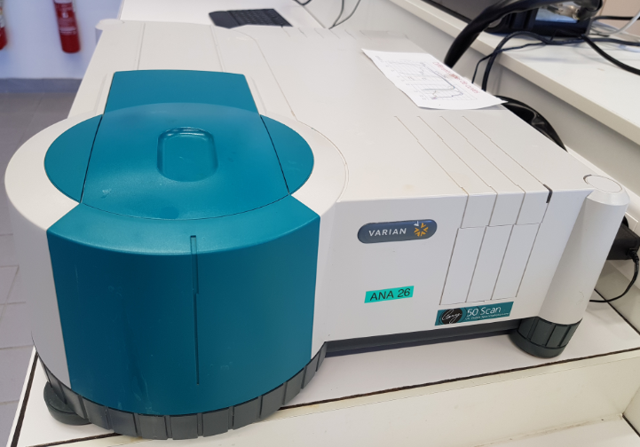
Figure 1 Instrument
This instrument is controlled by the software CARY Win UV. Manual instructions is provided on Moodle.

Cell

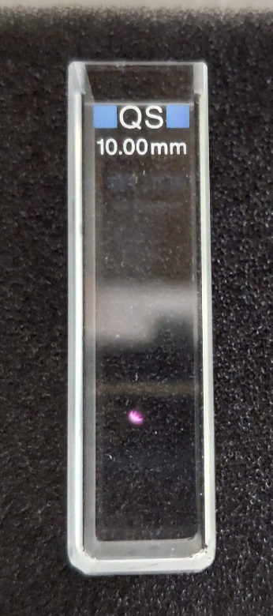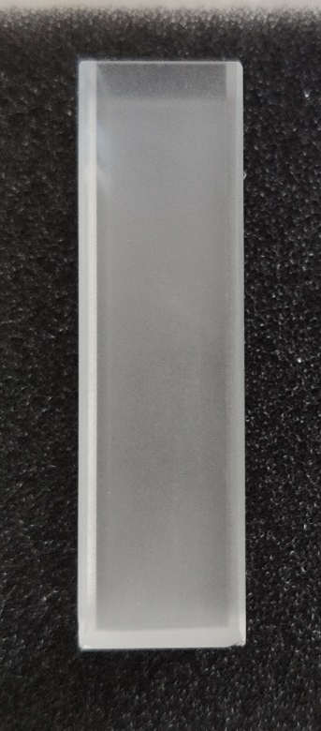
Figure 2 Front (clear) and side (frosty) of the cell

Cell used during the lab work optical path 1 cm. The cell is fragile, it’s made of quartz and costs around 150€.
Fill the cell volume to 3/4. Rinse carefully twice before drying of the external front side before any measurment.

Cell in the instrument

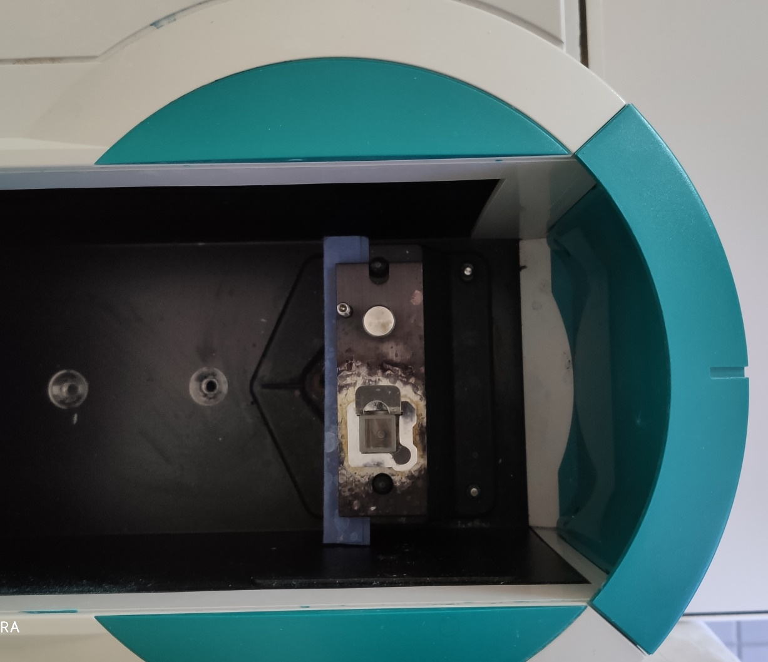
Clear part of the cell in the direction of the beam
Beam direction
Figure 3 Opened instrument from above

